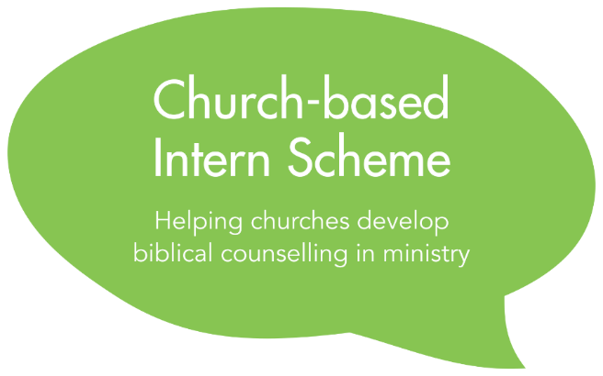
Application Form
To be completed by the church leader

2023
Privacy Notice
The information in this due diligence form will be processed on the legal basis of contract and special category information is collected and processed on the legal basis of not-for-profit under Article 9(2)(d) of the General Data Protection Act by the Director of the Intern Scheme. Application forms will be stored and shared in a secure manner with nominated members of the staff of Biblical Counselling UK for the purposes of assessing applications and administering the Scheme. Application forms of accepted candidates will also be shared with their nominated BCUK mentor.

Application forms of candidates who accept a place on the Scheme will be deleted after two years, at the end of the Scheme or at the request of an Intern upon leaving the Scheme, if sooner. Application forms of unsuccessful candidates will be deleted in September 2023. Application forms of candidates who are given a deferred place will be kept until the end of their involvement in the Scheme as we will ask candidates to update the form with edits or new information before beginning as an Intern. Our full privacy notice is available on our website. Please contact the Director of the Intern Scheme at interns@bcuk.org with any questions.

Please complete this form by typing in the spaces indicated.

Section 1: Church details
Church Name | Click here to enter text.
Church Denomination / Network | Click here to enter text.
Church Website | Click here to enter text.
Senior Pastor | Click here to enter text.
Name and position of church leader completing this section of the application (if not the senior pastor) | Click here to enter text.
Email | Click here to enter text.
Phone number | Click here to enter text.

Section 2: Interest in Biblical Counselling
Please describe what connection or contact you or others in church leadership have had with biblical counselling.
Click here to enter text.
Please describe how the vision of biblical counselling as held by BCUK supports your vision for your church.
Click here to enter text.

Do you or others within church leadership have any concerns or questions about BCUK’s approach to ministry or biblical counselling? If so, what would help to address those questions or concerns?
Click here to enter text.

Please outline how your church arrived at the decision to apply to the Intern Scheme.
Click here to enter text.

Section 3: Counselling Ministry Proposal
Please outline below your proposal for the way in which a biblical counselling mindset to ministry might be introduced or developed in your church or local context. What would your goals be for Year One?
Click here to enter text.

If accepted on to the Intern Scheme, a key goal for the first year is to discern whether you as a church (alongside the nominated Intern) might pursue the church growth track or the counselling track. Please indicate which track you are considering at this present time.
Click here to enter text.

Please outline why you are considering the track you have indicated above.
Click here to enter text.

If your proposed Intern is not given a place on the desired track for Year Two, how will that impact any ministry plans?
Click here to enter text.

Section 4: Financial Information
Are you intending to apply for a grant from BCUK? If yes, please email interns@bcuk.org for a grant application form and please submit the completed form together with the rest of the application documents. Please read the Before You Apply document for information about the grant.

Click here to enter text.

Section 5: Local Accountability Arrangements
☐ Please tick this box to confirm that the proposed local supervisor has given you their permission to give BCUK their contact details for the purpose of administering the Scheme.
Name of proposed Local Supervisor | Click here to enter text.
Position in the church | Click here to enter text.
Email | Click here to enter text.
Phone number | Click here to enter text.

Section 6: Safeguarding Arrangements
☐ Please tick this box to confirm that the designated safeguarding officer or lead safeguarding person of your church has given you their permission to give BCUK their contact details for the purpose of administering the Scheme.
Name of Safeguarding Officer/Lead Contact | Click here to enter text.
Email | Click here to enter text.
Phone number | Click here to enter text.

What training in the recognition and response to abuse has the applicant had? If none, how will you ensure the applicant is given suitable training before the start of the Intern Scheme?

Click here to enter text.

------------------------------------------------------------------------------------------------------------------------
Part 3 –Submitting your Application

To submit your application:
- Save this document as a “.docx” document with the following filename:
[applicant’s surname]_[applicant’s first name]_[intern-scheme]
For example: Smith_John_intern-scheme.docx

- The Church Leader should email this document, together with the completed Due Diligence form, the Individual’s Application form and the Grant Application Form (if applicable) to:
interns@bcuk.org

