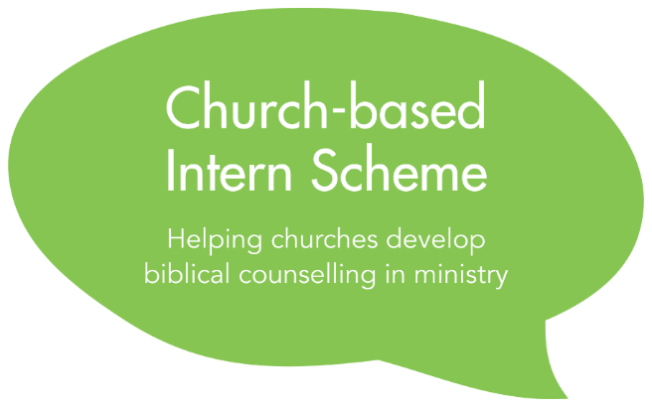

Due Diligence Form
September 2023 Intake

Privacy Notice
The information in this due diligence form will be processed on the legal basis of contract and special category information is collected and processed on the legal basis of not-for-profit under Article 9(2)(d) of the General Data Protection Act by the Director of the Intern Scheme. Application forms will be stored and shared in a secure manner with nominated members of the staff of Biblical Counselling UK for the purposes of assessing applications and administering the Scheme. Application forms of accepted candidates will also be shared with their nominated BCUK mentor.
Application forms of candidates who accept a place on the Scheme will be deleted after two years, at the end of the Scheme or at the request of an Intern upon leaving the Scheme, if sooner. Application forms of unsuccessful candidates will be deleted in September 2023. Application forms of candidates who are given a deferred place will be kept until the end of their involvement in the Scheme as we will ask candidates to update the form with edits or new information before beginning as an Intern. Our full privacy notice is available on our website. Please contact the Director of the Intern Scheme at interns@bcuk.org with any questions.

To be completed by the senior pastor of the applicant’s church

Section 1: Personal Details

Please complete this form by typing in the spaces indicated

Name of applicant | Click here to enter text.
Name of church | Click here to enter text.
Your name | Click here to enter text.
Your position | Click here to enter text.
Your email address | Click here to enter text.
How long have you known the applicant?
Click here to enter text.

Section Two: Recruitment
In addition to the application to Biblical Counselling UK’s Intern Scheme, we expect churches to conduct their own recruitment of the Intern (whether as employee or voluntary worker) in accordance with the Safer Recruitment best practice in place at your church.
☐ | We have or will carry out our own recruitment process of the individual as an employee or voluntary worker of the church in accordance with our current policies.

Please read: You’ll notice language in the documents about whether the Intern will be a voluntary worker or employed staff of your church. It is important for you and your church to understand which category the Intern falls into.
Voluntary Workers: A voluntary worker does not work voluntarily but is under a contractual obligation to provide the services for which she/he is engaged. Voluntary workers are not paid. Just like a volunteer, a genuine voluntary worker is exempt from receiving the National Minimum Wage. It is essential they must not receive remuneration for the work they do.
Often, ministry trainees or apprentices in a church will be voluntary workers. A voluntary worker has a contract specifying working hours, who they are accountable to, etc. but they are not entitled to the same employment rights as an employee. They are allowed to receive subsistence (reimbursement of food and drink consumed while volunteering) and/or accommodation which is reasonable given their role, but they do not receive a salary or any other benefit-in-kind.
Employed Staff: If the Intern is already an employee of the church or will become an employee at the beginning of their Intern role, the church can apply for a grant from Biblical Counselling UK to help fund the Intern’s salary. As an employee, the Intern should receive at least the national minimum wage and have an employment contract. They will be entitled to employment rights such as statutory sick pay, maternity/paternity pay, paid annual leave, employer’s pension contributions, etc.).
Occasionally, church staff are employed by a separate trust or grant-making body. If the Intern is to be an employee of one of these, it is the trust or grant-making body that should apply for the grant from BCUK.
Volunteers: A volunteer provides their services voluntarily – there is no mutuality of obligation. For this reason they should not be singing any form of contract, although an informal ‘volunteer agreement’ is allowed, often phrased in terms of hopes and expectations rather than obligations. As with voluntary workers, volunteers receive no salary from their church. Church members offering to serve on teams such as the Sunday School rota would be classed as volunteers. It is unlikely an Intern would be regarded as a volunteer – they are more likely to be a voluntary worker or employee.
Please state which category you envision the applicant to be in:
Click here to enter text.

Section 3: Background Checks & Safeguarding
We require churches participating in the Intern Scheme to carry out an enhanced DBS check (or basic check if enhanced is not possible) before the applicant commences ministry.
Churches must also ensure the applicant has or will receive updated safeguarding training (no more than two years old) before the applicant commences ministry.
Please tick the relevant box(es) below:
☐ | We have already carried out an enhanced DBS check (or similar) on the applicant that is relevant to the area of ministry they will be in if accepted as an Intern and have provided updated safeguarding training.
☐ | The DBS we have obtained does not show any concerns.
☐ | We will carry out an enhanced DBS check (or similar) on the applicant before the applicant commences ministry and provide safeguarding training.
NB: Where an enhanced DBS is not possible to obtain due to the change in which roles are applicable, we ask that churches complete a Basic Check and arranges to have the Intern sign a Declaration Form if possible. The NSPCC provide a template here.
Click here to enter text.

Do you have any concerns about behaviour now or in the past which might raise questions about this person’s suitability for this type of ministry?
Click here to enter text.

To submit the due diligence form:
- Save this document as a “.docx” document with the following filename:
[applicant’s surname]_[applicant’s first name]_[DD].docx]
For example: Smith_John_DD.docx

- Email this document together with the Individual’s Application form, the Church Leader Application form and Grant Application form (if applicable) to:
interns@bcuk.org

