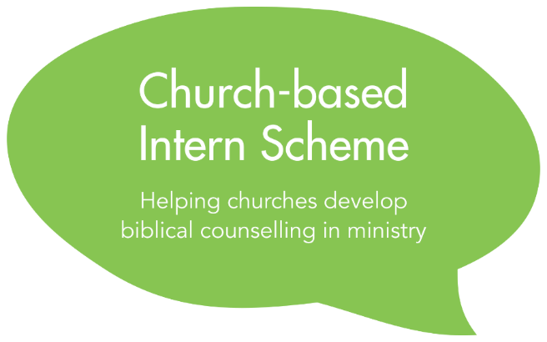
Application Form
To be completed by the applicant

2023
Privacy Notice
The information in this due diligence form will be processed on the legal basis of contract and special category information is collected and processed on the legal basis of not-for-profit under Article 9(2)(d) of the General Data Protection Act by the Director of the Intern Scheme. Application forms will be stored and shared in a secure manner with nominated members of the staff of Biblical Counselling UK for the purposes of assessing applications and administering the Scheme. Application forms of accepted candidates will also be shared with their nominated BCUK mentor.

Application forms of candidates who accept a place on the Scheme will be deleted after two years, at the end of the Scheme or at the request of an Intern upon leaving the Scheme, if sooner. Application forms of unsuccessful candidates will be deleted in September 2023. Application forms of candidates who are given a deferred place will be kept until the end of their involvement in the Scheme as we will ask candidates to update the form with edits or new information before beginning as an Intern. Our full privacy notice is available on our website. Please contact the Director of the Intern Scheme at interns@bcuk.org with any questions.

Please complete this form by typing in the spaces indicated.

Section 1: Personal Details

Click the icon below to insert a recent photo of yourself (or email it to us with your application). Your photo will help the Director of the Intern Scheme to recognise Interns in the video calls.

Title | Click here to enter text.
First Name | Click here to enter text.
Surname | Click here to enter text.
Email | Click here to enter text.
Mobile | Click here to enter text.
Home Telephone | Click here to enter text. | Daytime telephone | Click here to enter text.

Address | Click here to enter text.
Nationality  Age | Click here to enter text.  Click here to enter text.

Current Occupation  If less than five years, please give details and dates of previous occupation(s) over the past 5 years | Click here to enter text.

Name and denomination / network of your current church | Click here to enter text.
How long have you been involved with this church? | Click here to enter text.

Section 2: Relevant Training
Please provide details of the training you have received. You should include: details of the college or organisation; the course(s) taken, including dates; qualifications or certificates awarded. Please give details of any practical placements.
Biblical Counselling | Click here to enter text.
Theological Training | Click here to enter text.
Secular Counselling | Click here to enter text.
Ministry Training | Click here to enter text.
Other relevant training | Click here to enter text.

If you have not taken all the modules offered in the BCUK Certificate Course, including the Summer Intensive, please provide details of how and when you plan to take them:

Click here to enter text.

Please name a recent BCUK Recitation Instructor or Tutor who can comment on your engagement with a recent module. We will contact them for a brief comment on your grasp of biblical counselling.

Click here to enter text.

Click here to enter text.

In regard to safeguarding matters, what training in the recognition and response to abuse have you had? If none, how will you plan to receive suitable training before the start of the Intern Scheme?

Click here to enter text.

Section 3: Relevant Experience
Please provide brief details of your counselling experience (both formal and informal where applicable). Where able, describe the manner in which you were involved, the time frame of involvement and estimated number of people you have walked alongside.
Click here to enter text.

How has your gifting in counselling / biblical counselling been confirmed through those experiences?
Click here to enter text.

What are your weaknesses pertaining to counselling and/or pastoral ministry? How have others described or been impacted by those weaknesses?
Click here to enter text.

How have you helped your church grow towards a culture of interpersonal ministry?
Click here to enter text.

Please provide brief details of any other ministry experience (eg in your church or in a para-church organisation)
Click here to enter text.

Please list your current responsibilities in your local church, and any other areas of service you have been involved with in the past 10 years
Click here to enter text.

Section 4: Personal Statement
How and when did you become a Christian? Briefly describe your growth as a Christian. (word limit: 400 words)
Click here to enter text.

Briefly describe the development of your interest in biblical counselling. (word limit: 400 words)
Click here to enter text.

How, personally, have you been impacted by the courses you have taken through BCUK or CCEF? In other words, in what specific ways have you grown in love for God and for others as a result of your studies?
Click here to enter text.

Do you have any questions and/or areas of disagreement in respect of BCUK’s approach to ministry and biblical counselling?
Click here to enter text.

How much time (ie hours per week) will you be able to devote to the Scheme?
Click here to enter text.

Are you aware of any current life circumstances (eg caring for elderly parents) or personal issues (eg health concerns) that may impact your involvement in the Scheme?
Click here to enter text.

Section 5: Goals
If accepted on to the Intern Scheme, a key goal for the first year is to discern whether you (along with your church) might pursue the church growth track or the counselling track. Please indicate which track you are considering at this present time.
Click here to enter text.

Please outline why you are considering the track you have indicated above.
Click here to enter text.

If you are not given a place on your desired track for Year Two, how will that impact your future plans?
Click here to enter text.

How might you encourage the growth of biblical counselling ministry in your church in light of the giftings, experience and opportunities God has given you?
Click here to enter text.

What specific personal goals (both character and skills-related) do you have for the Scheme?
Click here to enter text.

Section 6: References
1) Ministry Referee (who has known you for at least two years and is able to comment on your skill in personal ministry; ideally this should not be the senior pastor of your church as they have to fill out the Due Diligence form.)
☐ Please tick this box to indicate that your ministry referee has given you their permission to give us their contact details for the purpose of our contacting them to request a reference.
Name | Click here to enter text.
Email | Click here to enter text.
Daytime telephone | Click here to enter text.
Capacity in which they know you | Click here to enter text.

2) Personal Referee (a mature Christian who has known you for more than five years and is able to comment on your personal spiritual growth; this should not be the senior pastor of your church)
☐ Please tick this box to indicate that your personal referee has given you their permission to give us their contact details for the purpose of our contacting them to request a reference.
Name | Click here to enter text.
Email | Click here to enter text.
Daytime telephone | Click here to enter text.
Capacity in which they know you | Click here to enter text.

Section 7: Applicant’s declaration
Please confirm your understanding of and consent to the following by ticking the box next to each statement. These statements are discussed in full in the Before You Apply document.
☐ | I understand that submitting an application to the Intern Scheme does not guarantee a place on the Intern Scheme.
☐ | The responsibilities and time commitments of the Intern Scheme are realistic and feasible for me.
☐ | I understand that the schedule of the Scheme runs from September 2023 to August 2024, with a second year offered where engagement with the first year is satisfactory.
☐ | I understand that there will be an in-person meeting in October 2023 (date tbd) and my attendance will be required if accepted onto the Intern Scheme.
☐ | I understand my pastor / church leader will need to complete and submit a Due Diligence form about me as part of the application process. I have read the questions on the Due Diligence form and the privacy notice on the Due Diligence form.
☐ | I confirm my agreement with the Biblical Counseling Coalition’s doctrinal and confessional statements if accepted as an Intern. Available to read here and here.
☐ | I understand that most monthly training meetings and peer supervisions will take place online using Zoom. I understand that I need to have quality internet access to participate in these.
☐ | I understand that a key goal for Year One is discerning which track to pursue in my second year. I understand that my own desires and the needs of the church may change over this year.
☐ | I understand that all parties (me, my local church and BCUK) must unanimously support which track I pursue in my second year. I understand that if there is not a unanimous agreement and alternative solutions are not satisfactory, the Internship will be discontinued, and a second year will not be offered.

Submitting your Application

To submit your application:
- Save this document as a “.docx” document with the following filename:
[applicant’s surname]_[applicant’s first name]_[intern-scheme]
For example: Smith_John_intern-scheme.docx

- Email your completed document to your church leader who will be filling out the Church Leader Application Form. They will submit all documents together to interns@bcuk.org

