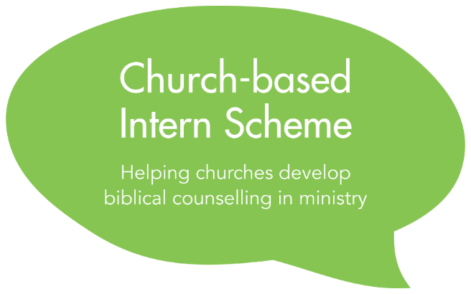

Due Diligence Form
September 2019 Intake

Privacy Notice
The information in this due diligence form will be processed on the legal basis of contract and special category information is collected and processed on the legal basis legitimate interest under Article 9(2)(d) of the General Data Protection Act by the Director of the Intern Scheme. Application forms will be stored and shared in a secure manner with the Executive Director, Senior Administrator and members of the Executive Committee of Biblical Counselling UK for the purposes of assessing applications and administering the Scheme.
Application forms of candidates who accept a place on the Scheme will be deleted after two years, at the end of the Scheme or at the request of an Intern upon leaving the Scheme, if sooner. Application forms of unsuccessful candidates will be deleted in September 2019. Our full privacy notice is available on our website. Please contact the Director of the Intern Scheme at interns@biblicalcounselling.org.uk with any questions.

To be completed by the senior pastor of the applicant’s church

Please complete this form by typing in the spaces indicated

Name of applicant | Click here to enter text.
Name of church | Click here to enter text.
Your name | Click here to enter text.
Your position | Click here to enter text.
Your email address | Click here to enter text.

We require churches participating in the Intern Scheme to carry out an enhanced DBS check before the applicant commences ministry. Please tick the relevant box below:
☐ | We have already carried out an enhanced DBS check on the applicant
☐ | We will carry out an enhanced DBS check on the applicant before the applicant commences ministry

Do you have any concerns about behaviour now or in the past which might raise questions about this person’s suitability for this type of ministry?
Click here to enter text.

Where relevant, please comment on the support of the applicant’s immediate family for them undertaking biblical counselling ministry.
Click here to enter text.

- Save this document as a “.docx” document with the following filename:
[applicant’s surname]_[applicant’s first name]_[DD].docx]
For example: Smith_John_DD.docx

- Email this document together with the Application form and Grant Application form (if applicable) to:
interns@biblicalcounselling.org.uk

