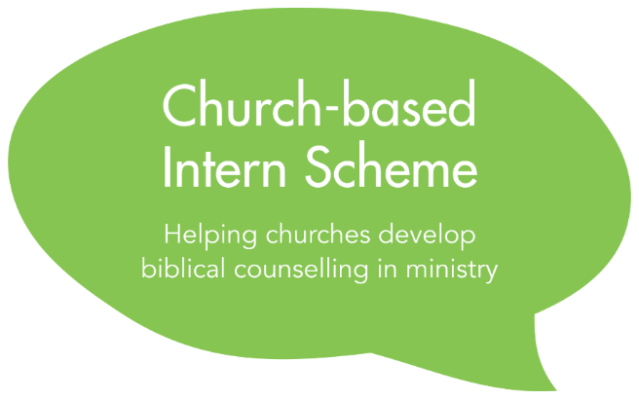
Application Form
2018
Privacy Notice
The information in your application will be processed on the legal basis of contract by the Scheme Co-ordinator. Application forms will be stored and shared in a secure manner with the Executive Director, Senior Administrator and Executive Committee of Biblical Counselling UK and the Scheme Mentors for the purposes of assessing applications and administering the Scheme.
Application forms of candidates who accept a place on the Scheme will be deleted after two years, at the end of the Scheme or at the request of an Intern upon leaving the Scheme, if sooner. Application forms of unsuccessful candidates will be deleted in September 2018.

Please complete this form by typing in the spaces indicated

Part 1 – To be completed by the applicant

Section 1: Personal Details

Title | Click here to enter text.
First Name | Click here to enter text.
Surname | Click here to enter text.
Email | Click here to enter text.
Mobile | Click here to enter text.
Home telephone | Click here to enter text. | Daytime telephone | Click here to enter text.
Click the icon below to insert a recent photo of yourself (or email it to us with your application). Your photo will help the Intern Co-ordinator recognise Interns in the video calls.

Address | Click here to enter text.
Nationality | Click here to enter text. | Age | Click here to enter text.

Current Occupation  If less than five years, please give details and dates of previous occupation(s) over the past 5 years | Click here to enter text.

Name and denomination of your current church | Click here to enter text.
How long have you been involved with this church? | Click here to enter text.

Section 2: Relevant Training
Please provide details of the training you have received. You should include: details of the college or organisation; the course(s) taken, including dates; qualifications or certificates awarded. Please give details of any practical placements.

Biblical Counselling | Click here to enter text.
Theological Training | Click here to enter text.
Secular Counselling | Click here to enter text.
Ministry Training | Click here to enter text.
Other relevant training | Click here to enter text.

Section 3: Relevant Experience
Please provide brief details of your counselling experience (both formal and informal)
Click here to enter text.

Please provide brief details of your ministry experience (eg in your church or in a para-church organisation)
Click here to enter text.

Please list your current responsibilities in your local church, and any other areas of service you have been involved with in the past 10 years
Click here to enter text.

Section 4: Personal Statement
How and when did you become a Christian? (word limit: 250 words)
Click here to enter text.

Briefly describe your growth as a Christian and the development of your interest in biblical counselling? (word limit: 400 words)
Click here to enter text.

Do you have any questions and/or areas of disagreement in respect of Biblical Counselling UK’s approach to ministry and biblical counselling?
Click here to enter text.

How much time (ie hours per week) will you be able to devote to the Scheme?
Click here to enter text.

Are you aware of any current life circumstances or personal issues (eg health concerns) that may impact your involvement in the Scheme?
Click here to enter text.

What specific personal goals (either character or skills-related) do you have for the Scheme?
Click here to enter text.

Section 5: References
1) Ministry Referee (who has known you for at least two years and is able to comment on your skill in personal ministry)
☐ Please tick this box to indicate that your ministry referee has given you their permission to give us their contact details for the purpose of our contacting them to request a reference.
Name | Click here to enter text.
Email | Click here to enter text.
Daytime telephone | Click here to enter text.
Capacity in which they know you | Click here to enter text.

2) Personal Referee (a mature Christian who has known you for more than five years and is able to comment on your personal spiritual growth; this should not be the senior pastor of your church)
☐ Please tick this box to indicate that your personal referee has given you their permission to give us their contact details for the purpose of our contacting them to request a reference.

Name | Click here to enter text.
Email | Click here to enter text.
Daytime telephone | Click here to enter text.
Capacity in which they know you | Click here to enter text.

Section 6: Applicant’s declaration
Please confirm your understanding of and consent to the following by ticking the box next to each statement:
☐ | The responsibilities and time commitments of the Intern Scheme are realistic and feasible for me.
☐ | I understand that the schedule of the Scheme runs from September 2018 to July 2019.
☐ | I understand that there will be an in-person meeting on 19 September 2018 and my attendance will be required.
☐ | I give my consent for Biblical Counselling UK to contact the two referees whose contact details I have provided to ask them to provide references for me.
☐ | I understand my pastor / church leader will need to complete and submit a Due Diligence form about me as part of the application process. I have read the questions on the Due Diligence form and the privacy notice on the Due Diligence form.
☐ | I understand that most monthly training meetings and optional peer consultations will take place online using Google Hangouts. I understand that I need to have quality internet access to participate in these.

------------------------------------------------------------------------------------------------------------------------
Part 2 – To be completed by the applicant’s church leader

Section 1: Church details
Church Name | Click here to enter text.
Church Denomination | Click here to enter text.
Church Website | Click here to enter text.
Senior Pastor | Click here to enter text.
Name and position of church leader completing this section of the application (if not the senior pastor) | Click here to enter text.
Email | Click here to enter text.
Phone number | Click here to enter text.

Section 2: Counselling Ministry Proposal
Please outline below your proposal for the introduction or development of a biblical counselling ministry in your church or local context. (In your proposal you should also include some information about longer-term plans, local accountability and support.)
Click here to enter text.

Section 3: Financial Information
Please give details of the funding which will be needed to develop this ministry. You should provide a breakdown of costs and your plans to meet those costs.

If you wish to apply for a grant from Biblical Counselling UK, please state the amount and duration (eg £x per year for 2 years).

Click here to enter text.

If Biblical Counselling UK were to offer the applicant a place on the Scheme, but no funding, how would that affect your plans for this ministry? | Click here to enter text.

Section 4: Local Accountability Arrangements
☐ Please tick this box to confirm that the proposed local supervisor has given you their permission to give Biblical Counselling UK their contact details for the purpose of administering the Scheme.
Name of proposed Local Supervisor | Click here to enter text.
Position in the church | Click here to enter text.
Email | Click here to enter text.
Phone number | Click here to enter text.

------------------------------------------------------------------------------------------------------------------------
Part 3 –Submitting your Application

To submit your application:
- Save this document as a “.docx” document with the following filename:
[applicant’s surname]_[applicant’s first name]_[intern-scheme]
For example: Smith_John_intern-scheme.docx

- The Church Leader should email this document, together with the completed Due Diligence form to:
amanda@biblicalcounselling.org.uk

